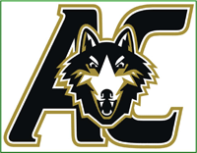
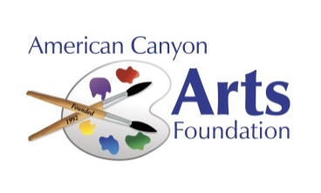

ACHS VISUAL & PERFORMING ARTS DEPT.
ACHS ARTS & MUSIC FEST-2024
Calling all Student Artists
OVERVIEW: The American Canyon Arts Foundation (ACAF), thanks to a generous grant from Napa Valley Presents, is proud to sponsor the second annual "ACHS Arts & Music Fest", featuring creative arts in multiple mediums, music and spoken word performances from ACHS students. This is also a fund-raising event for our American Canyon High School’s Visual And Performing Arts (VAPA) program. This is a FREE event, open to the Public.
DATE & TIME: Saturday, March 16, 2024, 1:00 - 4:00 pm
LOCATION: American Canyon High School, 3000 Newell Drive, American Canyon
ELIGIBILITY: All ACHS Students are Eligible and Encouraged to Enter!
CATEGORIES: Enter in one of the following categories:
1) Visual Arts & Painting 4) Music – Individual or group
2) Photography or Video 5) Dance
3) Sculpture & Ceramics 6) Theater or Spoken Word
JUDGING: The artwork and/or performances will initially be screened by each VAPA Instructor, to manage the size of the show (typically, 10-20 entries per categories 1-3; Five or less in categories 4-6). Judges will then review the art and select First, Second and Third places for each category. For performances, a time schedule will be emailed to the artists prior to the show. Note: Additional Awards for Outstanding Performances or Artwork may be provided, in addition to First, Second and Third place.
TO ENTER: Click on the QR Code and complete the form.
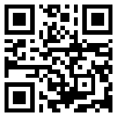
Or email the attached Entry Form to: AmCanArts@gmail.com
OR mail to American Canyon Arts Foundation, 101 W. American Canyon Rd, #508-163, American Canyon, CA 94503.
ENTRIES DUE: THURSDAY, FEBRUARY 29, 2024 (For special arrangements, contact Clarence Mamaril: clarencemamaril@gmail.com)
For More Info: Email AmCanArts@gmail.com or call (707) 567-6364
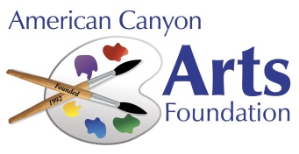

ACHS VISUAL & PERFORMING ARTS DEPT.
ACHS ARTS & MUSIC FEST-2024
Entry Form

Artist Name: ____________________________________________________________________
Grade: _____________________ Instructor: ________________________________
Address: ____________________________________________________________________
City/State: _____________________________________________ Zip: _________________
Email address: ____________________________________________________________________
Cell Phone: ________________________ Today’s Date: ______________________________
Artists will be contacted by email with exhibit/performance details, unless other arrangements are made.

Title/Description: _________________________________________________________________
Category (check one):
1) ___ Visual Arts & Painting 4) ___ Music – Individual or group
2) ___ Photography or Video 5) ___ Dance
3) ___ Sculpture & Ceramics 6) ___ Theater or Spoken Word
Exhibit Dimensions (if applicable): _____________________
Instructions:
- Please complete this entry form online by Thursday, February 29, 2024. You may also mail the completed form to ACAF, 101 W. American Canyon Rd #508-163, American Canyon CA 94503; or email to (AmCanArts@gmail.com). Call Clarence @ (707) 567-6364 to make other arrangements.
- Please note the title and artist on the back of your artwork, or provide some other form of identification, to properly track/judge it, and to avoid any confusion over ownership. Please include an email address so we can contact you in a timely manner, unless other arrangements have been made.
- Each VAPA Instructor will screen the artwork to manage the size of the show. Artwork to be included in the show will be brought to the Cafeteria on Friday, March 15.
- The Visual Artwork will be set up for display on Saturday, March 16, 2024, prior to noon. The show itself will run from 1pm to 4pm, at which time artwork will be on display, as well as live performances.
- Artwork must be picked up after the show on Saturday, March 16, 2024, at 5:00 pm, unless other arrangements are made.

